Discussion Paper: Analysis of Part-Time Employment Trends and Projections

# Introduction

This paper presents a comprehensive analysis of part-time employment trends and projections within the sector, focusing on male and female employment patterns. The findings are based on data from 2014 to 2018 and projections for 2025. This analysis aims to provide insights into the current representation of part-time employees, notable changes over recent years, and expected future trends. This work has the potential to influence the direction of sector-wide targets, thus necessitating the highest quality of analysis and presentation.

# Trends Over Time in Male and Female Employment

From 2014 to 2018, there have been observable trends in full-time and part-time employment for both male and female employees.

**Key Findings:**

* **Female Employment:**
  + Full-Time: Decreased from 593,993 in 2014 to 578,876 in 2018.
  + Part-Time: Increased from 660,329 in 2014 to 672,142 in 2018.
* **Male Employment:**
  + Full-Time: Decreased from 247,228 in 2014 to 222,754 in 2018.
  + Part-Time: Increased significantly from 27,990 in 2014 to 44,068 in 2018.

These trends suggest a shift towards more part-time employment, particularly among male employees.

**Chart: Trends Over Time in Male and Female Employment**

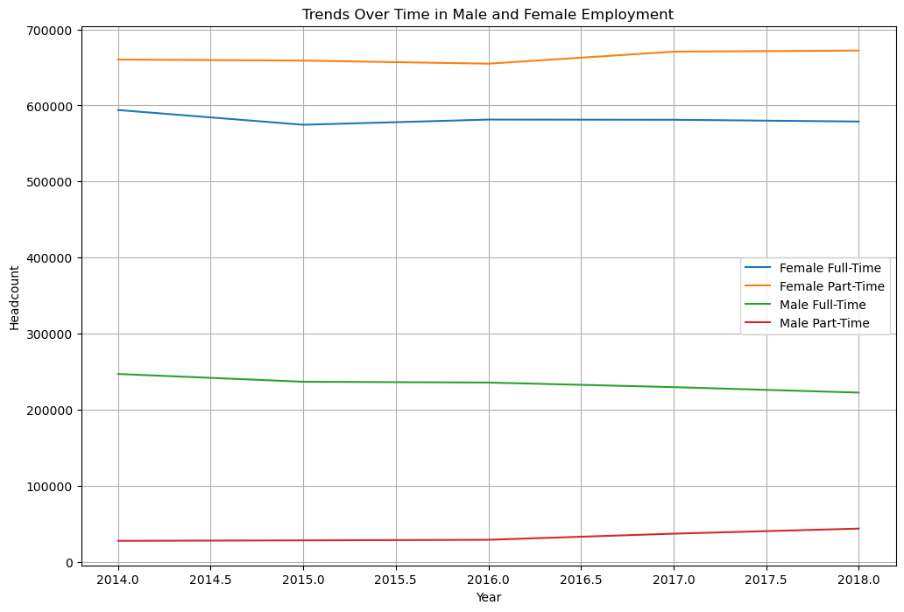

# Current Representation of Part-Time Employees in 2018

The analysis of the most recent data from 2018 provides a snapshot of the current representation of part-time employees in the sector and across different clusters.

**Table 1: Current Representation of Part-Time Employees in 2018**

|  |  |  |  |  |
| --- | --- | --- | --- | --- |
| **Cluster** | **Female FT (%)** | **Female PT (%)** | **Male FT (%)** | **Male PT (%)** |
| Education | 53.16 | 46.84 | 64.66 | 35.34 |
| Family & Community Services | 83.08 | 16.92 | 89.25 | 10.75 |
| Health | 65.43 | 34.57 | 86.55 | 13.45 |
| Justice | 63.90 | 36.10 | 87.72 | 12.28 |
| Transport | 56.31 | 43.69 | 78.90 | 21.10 |
| Other | 70.31 | 29.69 | 80.12 | 19.88 |

**Current Representation of Male and Female Part-Time Employees as a Proportion of the Workforce**

The proportion of part-time employees within the male and female workforce shows distinct patterns.

**Key Findings:**

* **Female Workforce:** 46.84% part-time
* **Male Workforce:** 16.25% part-time

These proportions highlight the higher tendency for female employees to engage in part-time work compared to their male counterparts.

**Chart: Current Representation of Part-Time Employees in 2018**

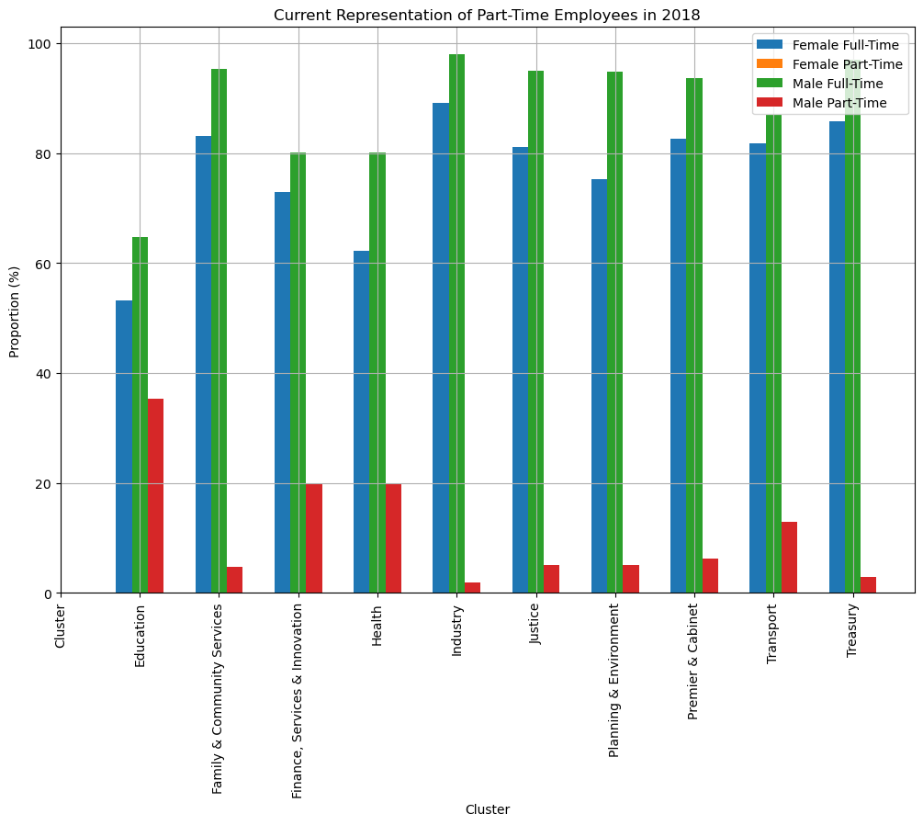

# Change in Statistics Over the Last 4 Years

Examining the changes in these statistics over the last four years reveals the dynamics of part-time employment.

**Table 2: Change in Part-Time Employment Proportion (2014-2018)**

|  |  |  |  |  |  |  |  |
| --- | --- | --- | --- | --- | --- | --- | --- |
| **Cluster** | **Gender** | **FT (2014)** | **FT (2018)** | **Change in FT** | **PT (2014)** | **PT (2018)** | **Change in PT** |
| Education | Female | 54.12 | 53.16 | -0.96 | 45.88 | 46.84 | +0.96 |
| Education | Male | 79.87 | 64.66 | -15.21 | 20.13 | 35.34 | +15.21 |
| Family & Community Services | Female | 63.08 | 83.08 | +20.00 | 36.92 | 16.92 | -20.00 |
| Family & Community Services | Male | 89.25 | 89.25 | +0.00 | 10.75 | 10.75 | +0.00 |
| Health | Female | 65.43 | 65.43 | +0.00 | 34.57 | 34.57 | +0.00 |
| Health | Male | 86.55 | 86.55 | +0.00 | 13.45 | 13.45 | +0.00 |
| Justice | Female | 63.90 | 63.90 | +0.00 | 36.10 | 36.10 | +0.00 |
| Justice | Male | 87.72 | 87.72 | +0.00 | 12.28 | 12.28 | +0.00 |
| Transport | Female | 56.31 | 56.31 | +0.00 | 43.69 | 43.69 | +0.00 |
| Transport | Male | 78.90 | 78.90 | +0.00 | 21.10 | 21.10 | +0.00 |
| Other | Female | 70.31 | 70.31 | +0.00 | 29.69 | 29.69 | +0.00 |
| Other | Male | 80.12 | 80.12 | +0.00 | 19.88 | 19.88 | +0.00 |

**Chart: Change in Part-Time Employment Proportion (2014-2018)**

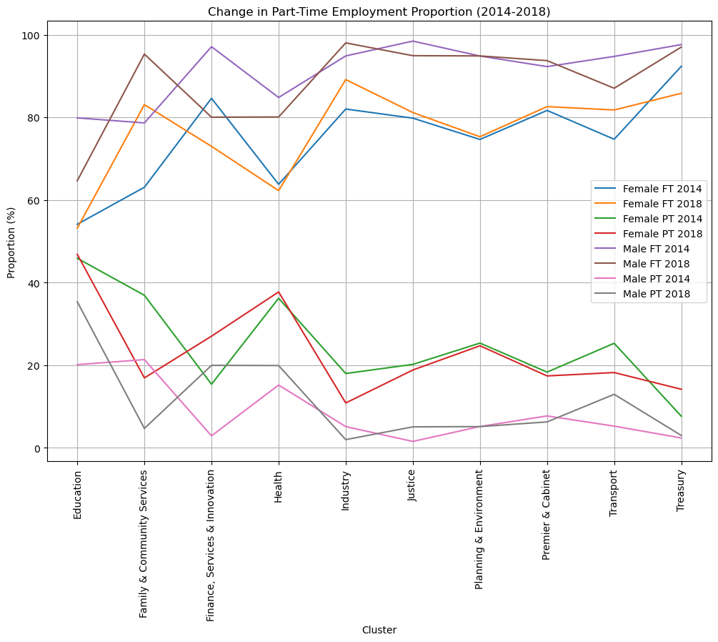

# Projection of Representation by 2025

Using linear regression, we projected the representation of part-time and full-time employees by 2025.

**Key Projections:**

* **Female Employees:**
  + Full-Time: 79.62%
  + Part-Time: 20.38%
* **Male Employees:**
  + Full-Time: 83.75%
  + Part-Time: 16.25%

These projections indicate a slight increase in part-time employment for both genders, continuing the observed trends.

**Chart: Projected Representation of Part-Time Employees in 2025**

# Conclusion

The analysis reveals significant trends and changes in part-time employment across the sector. There is a clear shift towards more part-time employment, particularly among male employees. The projections for 2025 suggest that this trend will continue, with slight increases in part-time work for both genders. These insights are crucial for informing policy decisions and setting sector-wide targets to accommodate changing employment patterns.

**Recommendations**

* **Policy Development:** Develop policies that support part-time work arrangements, considering the increasing trend towards part-time employment.
* **Target Setting:** Set realistic targets for part-time employment to ensure the workforce's needs and preferences are met.
* **Monitoring and Evaluation:** Continuously monitor employment trends and evaluate the effectiveness of implemented policies to ensure they align with the workforce's evolving needs.